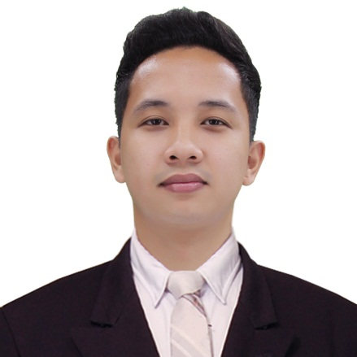
REFERENCES
- Engr. Paul Ryan A. Santiago
Instructor, AMA Computer College Malolos
0905-131-3357
- Engr. Atilano C. Mendoza
Businessman
0936-924-1914
OBJECTIVE
To gain more knowledge and skills in the field of Electronics and Communication Engineering, that will strengthen my education and professional skills and to significantly contribute to the company’s organizational objectives.
EDUCATION
- Bachelor of Science Electronics and Communication Engineering
AMA Computer College Malolos
Sumapang Matanda, Malolos City
A.Y. 2015-present
- Bachelor of Science in General Engineering
Bulacan State University-Bustos Campus
Bustos, Bulacan
A.Y. 2014-2015
- Balagtas National Agricultural High School
Pulong Gubat, Balagtas, Bulacan
A.Y. 2010-2014
- Gentle Shepherd Montessori
Siling Matanda, Pandi, Bulacan
A.Y. 2004-2010
SEMINARS ATTENDED
- IECEP NATIONAL STUDENT SUMMIT 2018
University of the Philippines, Quezon city
November 10, 2018
- Restricted Radiotelephone Operator’s (RLM) Certificate for Land Mobile Stations, Digital Mobile Radio, Amateur Radio, First Class Radiotelephone Operator)
Polytechnic University of the Philippines-Mabini Campus, Santa Mesa, Manila
October 22, 2018
- Solar Photovoltaic System Workshop
Malolos City
Dec 2017
- IECEP-Bulsu SC Excellerate Seminar 2017
Bulacan State University
November 18, 2017
- Basic Electro-Pneumatics
AMACC-MALOLOS
October 10, 2017
- Fluke Networks CCTT Associate Program
Bulacan State University
March 26, 2017
SKILLS
- Proficient of creating Local area network.
- Proficient of trouble shooting computer hardware, and installing operating system.
- Capable of trouble shooting electronic device.
- Proficient of using Microsoft Office applications
- Capable of using software applications such as Multisim, Picosoft, and Fluidsim.

ACHIEVEMENTS/ RESPONSIBILITIES
- President and Head BOD of IECEP-AMACC Malolos SC local organization
A.Y 2018-2019
- Vice President of IECEP-AMACC Malolos SC local organization
A.Y. 2017-2018
- Second trimester Dean’s lister
A.Y. 2017-2018
- First trimester Dean’s lister
A.Y. 2017-2018
- Second trimester Dean’s lister
A.Y. 2016-2017
- Computer hardware Servicing NCII Passer
March 2014

